Week 4: Backend Processing and User Authentication

4.1 Server-Side Components and Backend Development Foundations

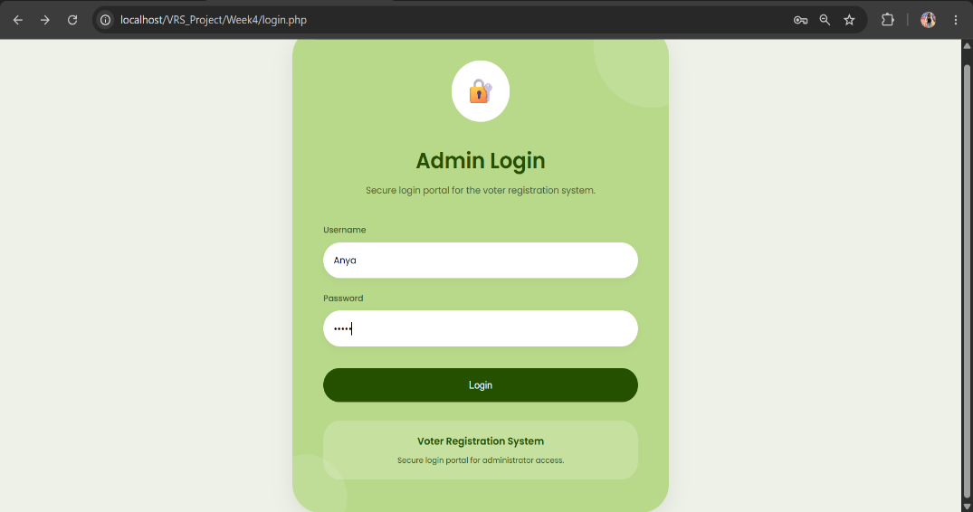
Figure 16: Admin Login Page

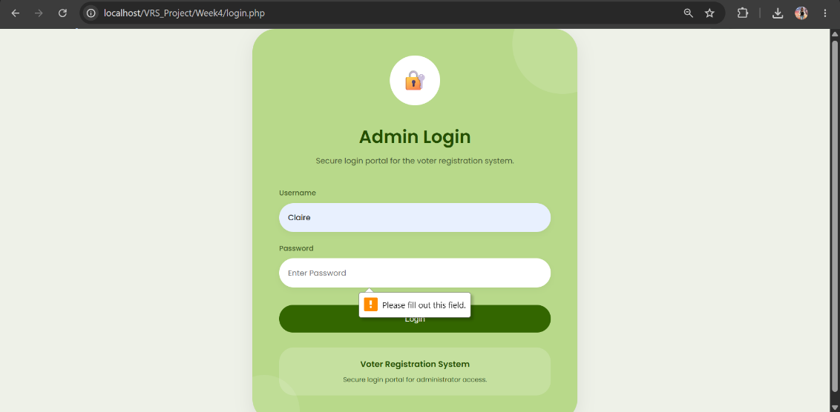
Figure 17: Form Validation System

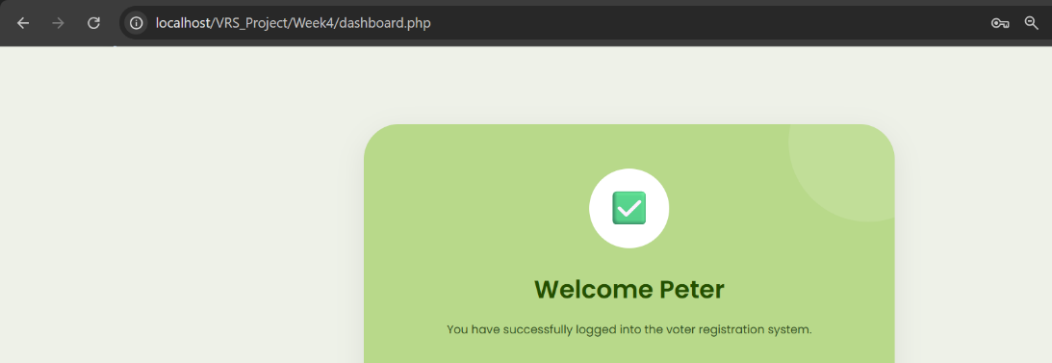
Figure 18: PHP Processing Page

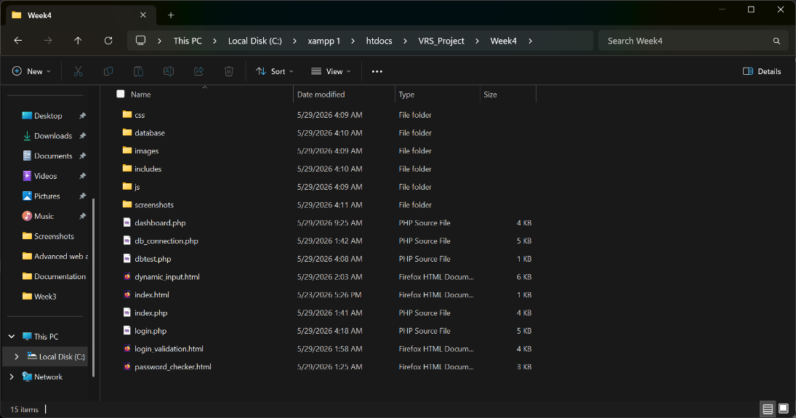
Figure 19: Backend Folder Structure

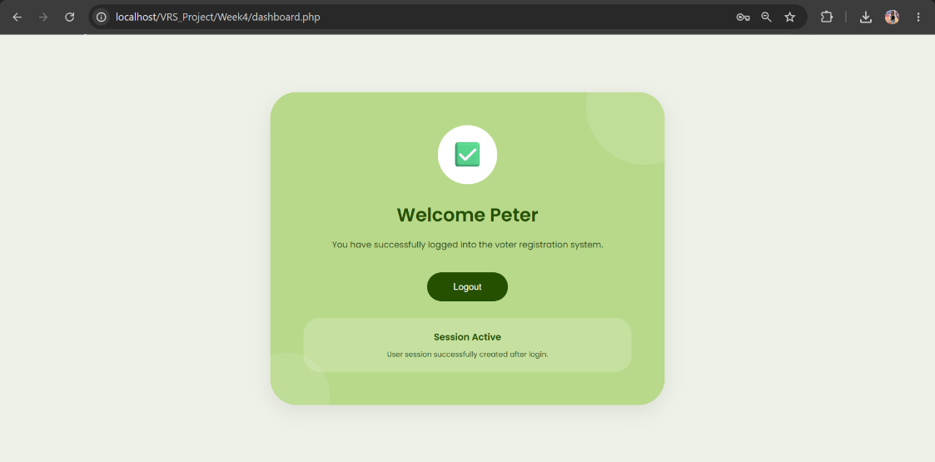
Figure 20: Session Welcome Page

